Day-4 Assignment
Q1. Connect a USB webcam to your computer, install any required drivers, and verify that the webcam works by opening the default camera app and capturing a photo.
Ans.
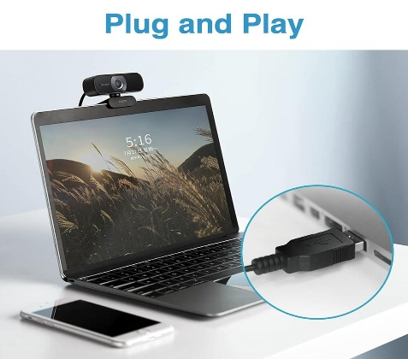
Step 1: Connect the webcam
- Plug the USB webcam into an available USB port.
- Wait a few seconds for Windows to detect it.
- If possible, connect it directly to the computer rather than through a USB hub.
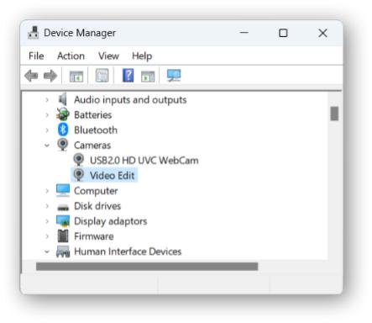
Step 2: Install or check the driver
- Right-click Start and open Device Manager.
- Expand Cameras (or Imaging devices).
- Check whether your webcam appears.
- Windows usually installs the required driver automatically. If it does not, use Windows Update or the webcam manufacturer's official website.
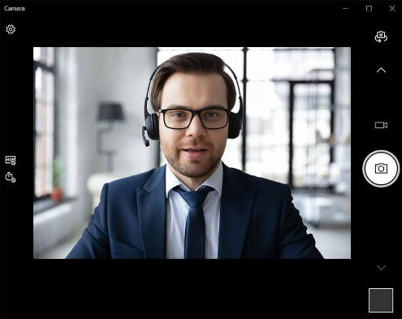
Step 3: Open the Camera app
- Press the Windows key.
- Type Camera.
- Open the Windows Camera app.
- If multiple cameras are available, switch cameras until the USB webcam preview appears.
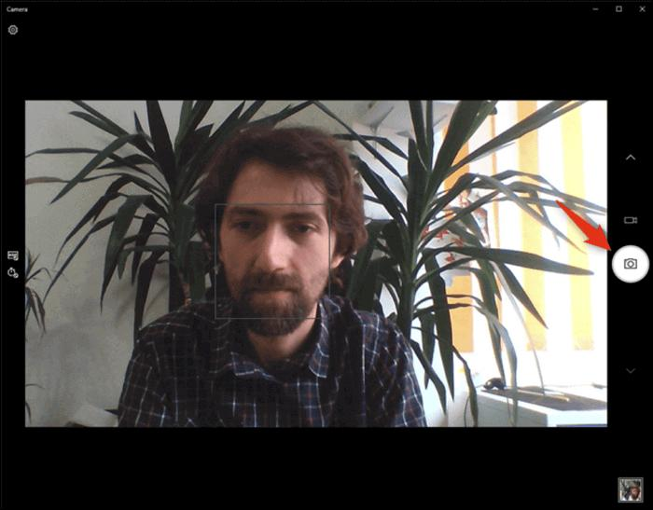
Step 4: Capture a photo
- Position the webcam and check the live preview.
- Click the Take photo button.
- Open the captured image thumbnail to confirm the photo was saved.
- Photos are usually saved in Pictures → Camera Roll.

Q2. Set up a local printer (USB or network), install the correct driver, and print a test page to confirm successful installation.
Ans.
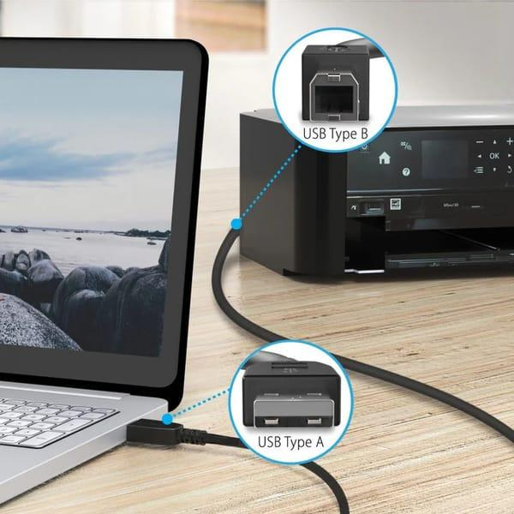
Step 1: Connect the printer
- USB printer: Turn on the printer and connect its USB cable to your computer.
- Network printer: Connect the printer and computer to the same network, or use the printer's supported network connection.
- Ensure the printer has paper and sufficient ink or toner.
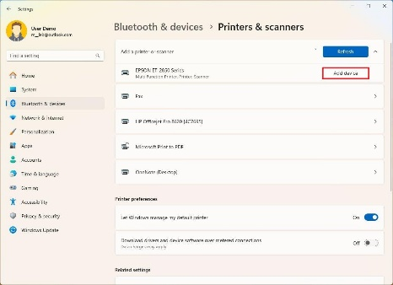
Step 2: Add the printer
- Open Start → Settings.
- Select Bluetooth & devices → Printers & scanners.
- Click Add device.
- Wait for Windows to detect the printer and click Add device beside its name.
- If it is not listed, select Add manually and follow the instructions.
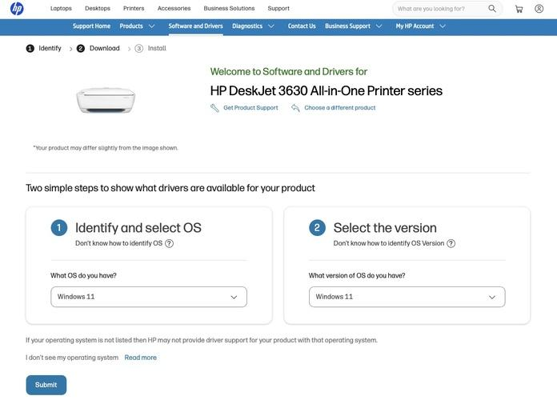
Step 3: Install the correct driver
- Find the printer's manufacturer and exact model number.
- Visit the manufacturer's official support website.
- Download the driver for your printer model and Windows version.
- Run the installer and follow the instructions.
- Return to Printers & scanners and confirm the printer is listed.
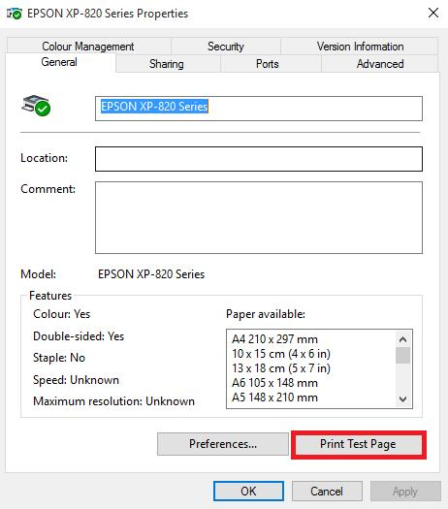
Step 4: Print a test page
- Open Settings → Bluetooth & devices → Printers & scanners.
- Select your installed printer.
- Open Printer properties. Depending on the driver, this may be under related settings.
- Click Print Test Page.
- Confirm that the page prints correctly.

Q3. Simulate a connectivity issue by unplugging the printer's USB cable, then use Windows Device Manager to identify and resolve the 'printer not detected' problem.
Ans.
Step 1: Simulate the connectivity issue
- Turn on the printer.
- Disconnect the printer's USB cable from the computer.
- Wait a few seconds to simulate a connection failure.
Step 2: Open Device Manager
- Right-click the Start button.
- Select Device Manager.
- Check the Printers, Print queues, and Universal Serial Bus controllers sections.
Step 3: Identify the problem
- Check for a yellow warning triangle or other error icon.
- The disconnected printer might disappear from Device Manager, or Windows might show an unknown device.
- A missing printer alone does not necessarily mean its driver is faulty.
Step 4: Reconnect the printer
- Reconnect the USB cable securely.
- Ensure the printer is powered on.
- Try another USB port if necessary.
Step 5: Scan for hardware changes
- In Device Manager, select your computer's name at the top.
- Click Action → Scan for hardware changes.
- Wait for Windows to detect the connected printer.
- Check the relevant device sections again for the printer.

Step 6: Verify the solution
- Open Settings → Bluetooth & devices → Printers & scanners.
- Confirm that the printer is listed.
- Print a test page to verify that it works.

Q4. A user reports that their webcam video is not displaying in Zoom, but it works in the default camera app. Troubleshoot and resolve the issue so the webcam works in both applications.
Ans.
Since the webcam works in the Camera app, the hardware is likely functioning. The issue may be caused by another application using the webcam, Zoom settings, privacy permissions, or the camera driver.
Step-by-step troubleshooting
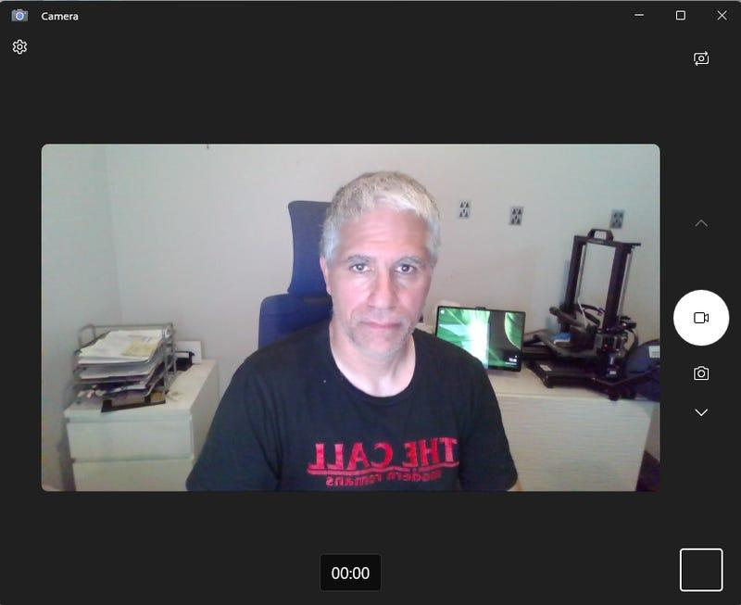
Step 1: Confirm webcam operation
- Open the Windows Camera app.
- Verify that live video is displayed.
- Close the Camera app completely before opening Zoom.
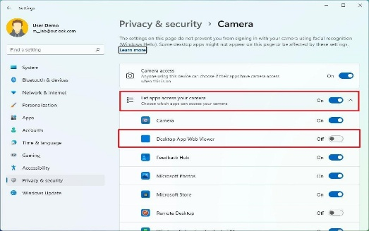
Step 2: Check camera permissions
- Open Settings → Privacy & security → Camera.
- Turn on Camera access.
- Turn on Let apps access your camera, if available.
- Enable camera access for desktop apps, ensuring Zoom can use the webcam.
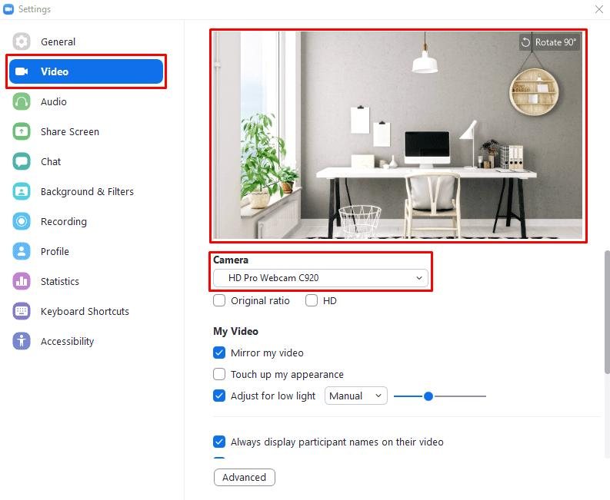
Step 3: Check Zoom video settings
- Open Zoom.
- Click your profile picture, then Settings → Video & effects (the name may vary by version).
- Under Camera, select the correct USB webcam.
- Check whether the video preview appears.
- If multiple cameras are listed, try the other available camera options.
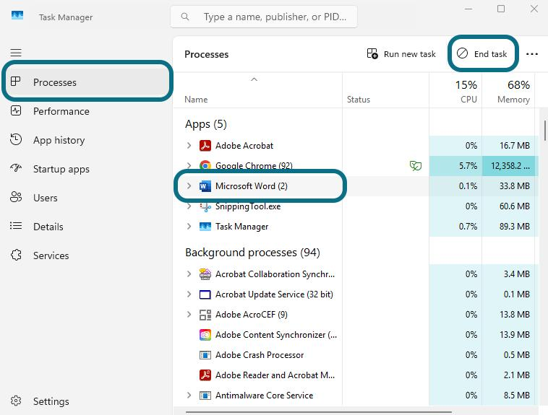
Step 4: Close conflicting applications
- Close the Camera app, browser video calls, Microsoft Teams, and other apps that might use the webcam.
- Exit Zoom completely and reopen it.
- If needed, restart the computer and test Zoom again.
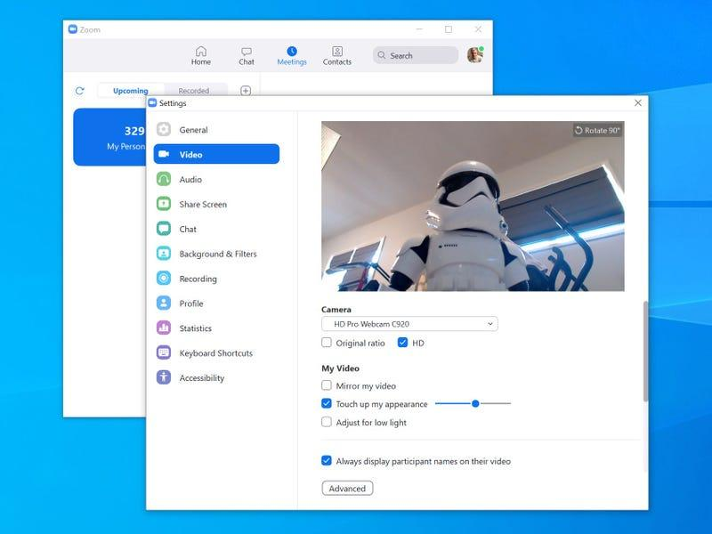
Step 5: Test the webcam in Zoom
- Open Zoom and return to video settings.
- Confirm that the webcam preview is visible.
- Join a test meeting or a permitted meeting and enable video.
- Confirm that your video is displayed.
If the issue persists
- Update Zoom using its built-in update option or the official Zoom website.
- Open Device Manager → Cameras, right-click the webcam, and select Update driver.
- Check whether security software is blocking camera access.
- Restart Windows and test again.

